**Step 1 : Installing Detectron 2**

Start installation of the required dependencies such as torch , use google colab to train the model as it satisfies the CUDA requirements ( NOTE : Don't forget to change the runtime type in the colab to GPU ) , and also mount your drive and move to the directory in which you want to save all the model files and output.

### all these installations are present in the cloab file provided

#mount Google Drive

from google.colab import drive

drive.mount('/content/drive')

%cd "/path/"

#Install dependencies

!pip install cython pyyaml==5.1

!pip install -U'git+https://github.com/cocodataset/cocoapi.git#subdirectory=PythonAPI'

import torch, torchvision

#Install detectron

!git clone https://github.com/facebookresearch/detectron2 detectron2_repo

!pip install -e detectron2_repo

**Step 2 : Prepare your custom dataset**

The Detectron2 accepts data in a certain format and we are in place to prepare the data set , the following steps will allow you to create one .

To prepare the data set we need a tool “labelme” , to install it first install Anaconda (it is not compulsory to use anaconda any other alternatives can also be used) then open anaconda prompt and follow the below code,

#install labellme

conda install -c conda-forge labelme

conda install -c conda-forge/label/cf202003 labelme

( For more information visit : <https://anaconda.org/conda-forge/labelme> )

To access the labelme open anaconda prompt and type labelme

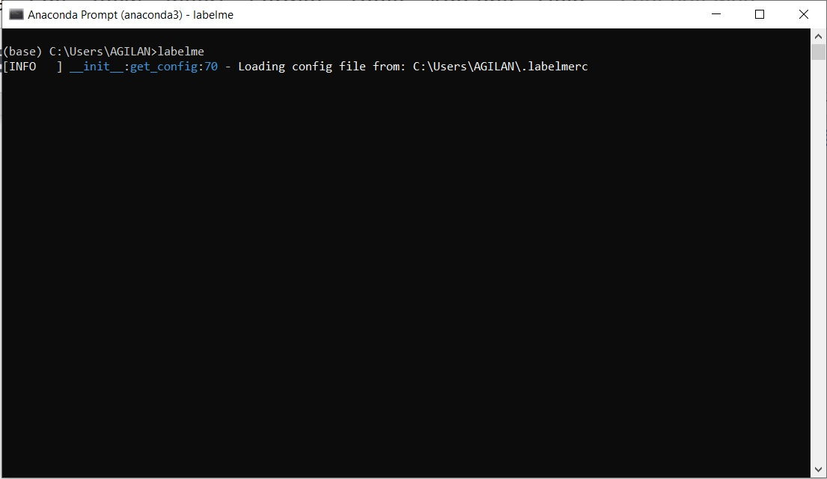

You will see a window opening like shown below

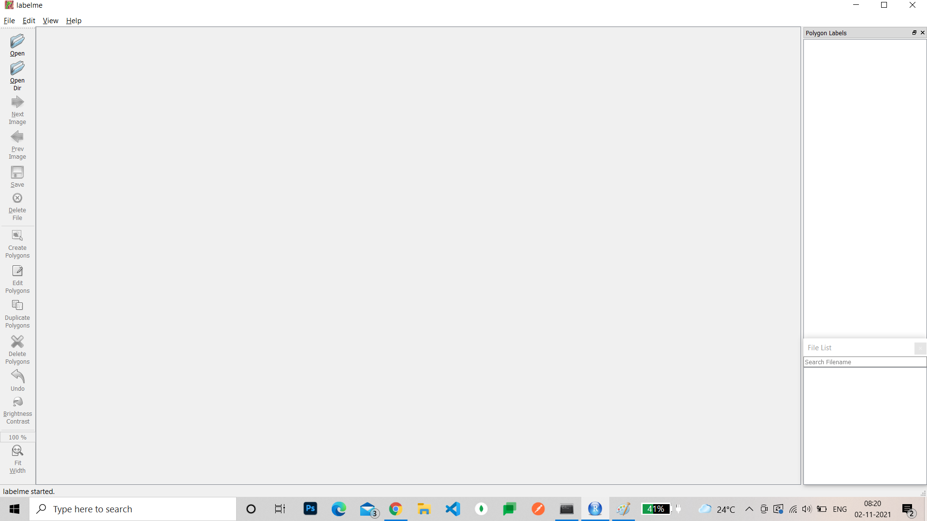

On the top left you can see an option to open a directory , click on it and choose the file where your images are stored .

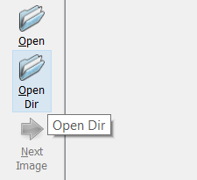

You can now see all your images loaded into the labelme

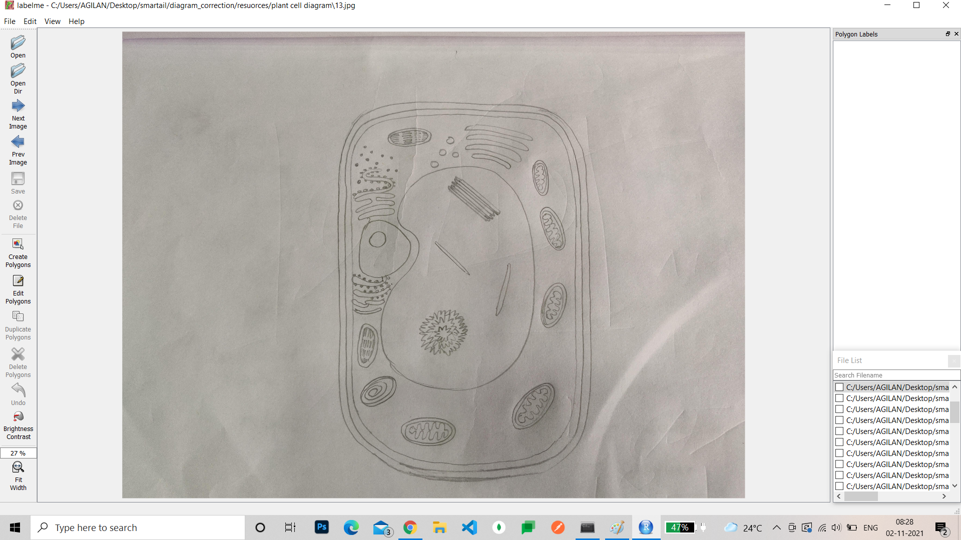

Now use the option create polygons on your left to annotate and label the parts

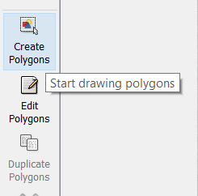

( NOTE : you can use ctrl + scroll to easily zoom in and out )

Draw the polygons to annotate the parts of the image

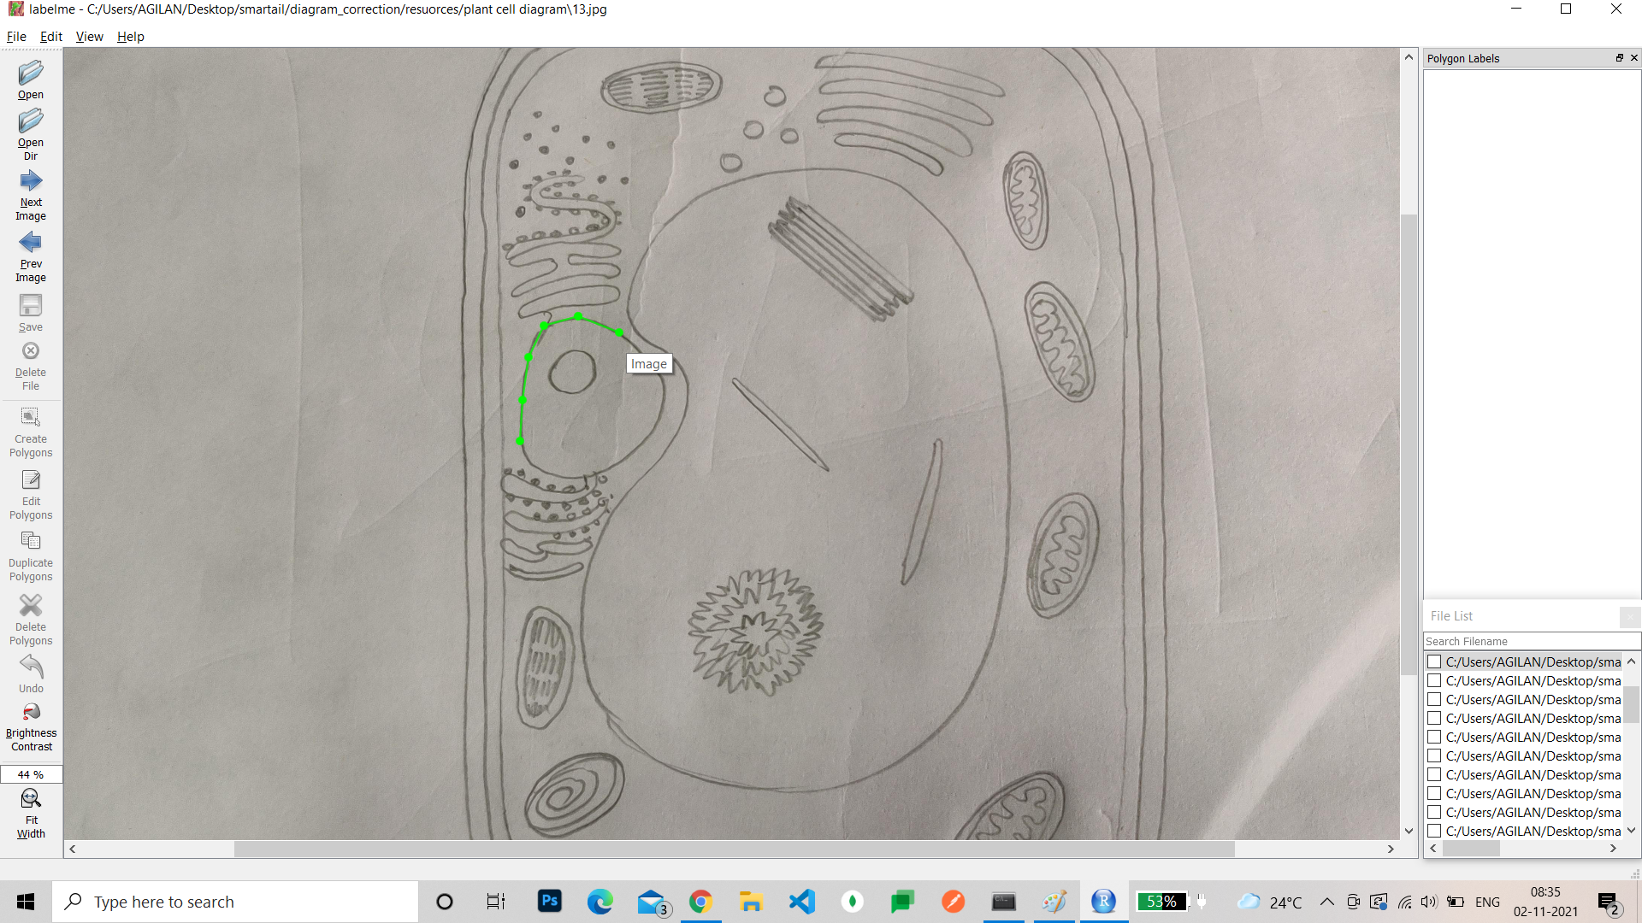

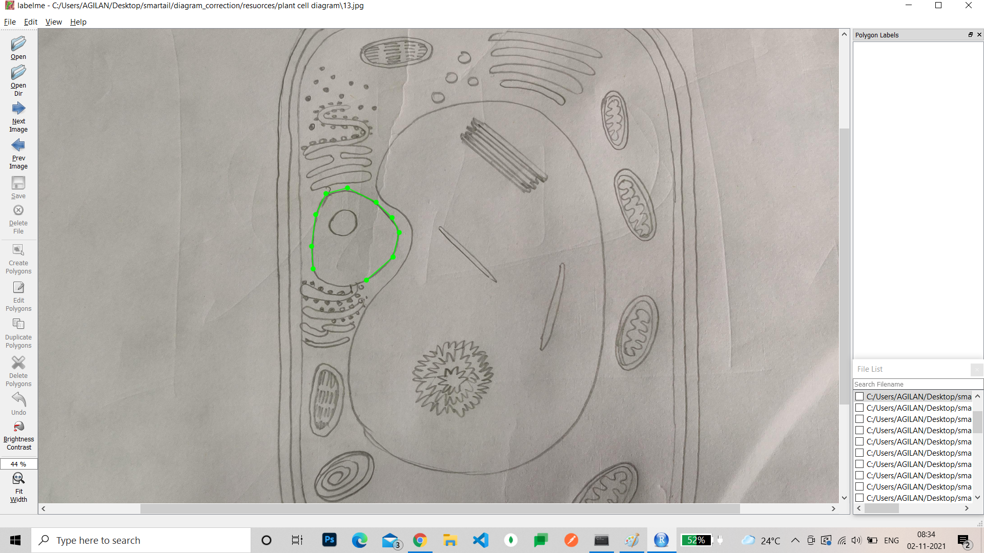

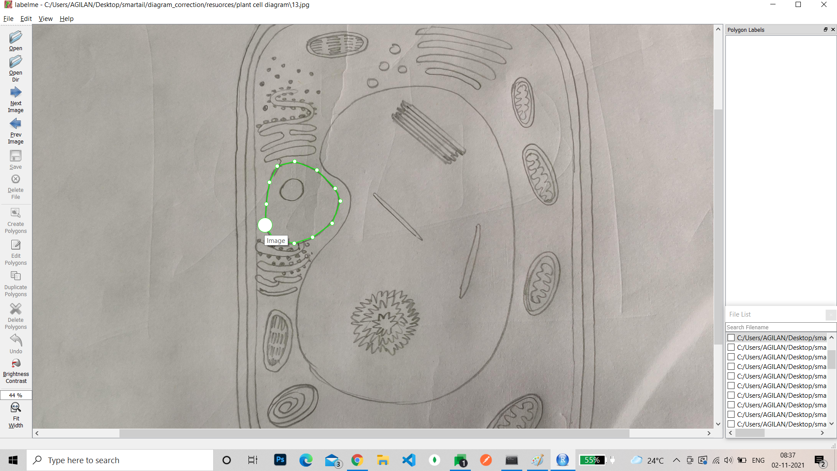

As you complete a polygon you can see a box popping up to you as below

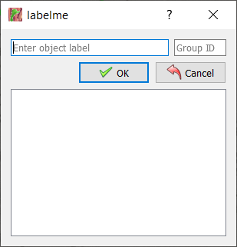

You can name the part that you have annotated above and select ok.

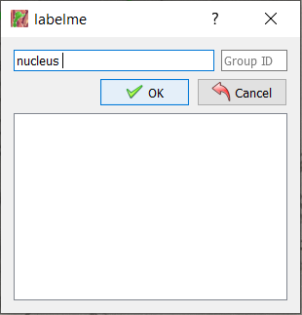

The next time when you annotate the same part you need not enter the name you will have the name already stored in the dialog box and you can just select that

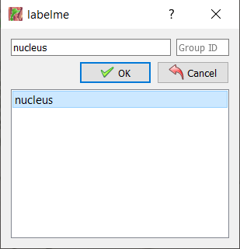

After completing annotation of all the parts select the save option on the left side, when directly save it without any name changes it will automatically save in the same directory where the image is and the name will be the same as the image name.

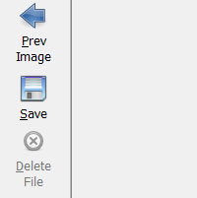

After saving select the next image option to move to the next image and use the prev image option to traverse backward.

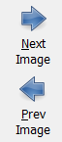

You can see all the annotation files in the directory where the original images are present

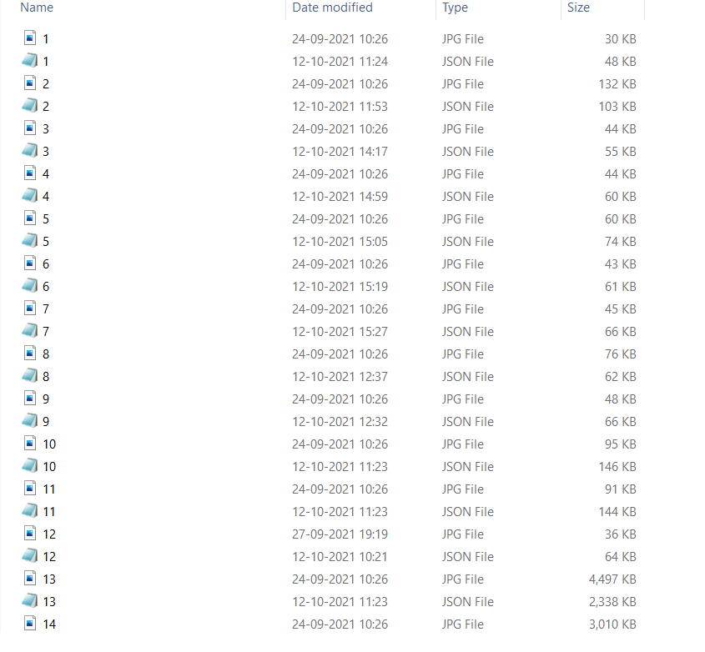

Now you can observe all individual annotations , but for proceeding with the model training we need to combine all the json files into a single json file.

Use the given link below to download the python file to combine the annotation files

<https://drive.google.com/file/d/1GRZVtcXJkBPG-c48W4Cg7XRO5l23kNvV/view?usp=sharing>

Download the file and run the file as below given format

#open cmd and move to the directory where the downloaded file is present

>python jsontococo.py “individual_json_path” --output “new_combined_json_name”.json

You can find a combined json file in the same place where your python file is present

**Step 3 : Upload required resources to drive**

Once the combined annotation is ready create a new file in your drive and upload the combined json into it, also upload the file where you have all the images for which we have annotated.

**Step 4 : Train and predict the model**

Use the colab file to and follow the steps(shells) to obtain a model trained reday of the chosen type.

**Step 4 : Download the required resources from drive**

As you open the file you have created in your drive you can observe many other files present in the directory, find the file which you have created for dumping the configuration data and download it.

Then open the file named output and find the file named “model_final.pth” which is the trained model for your dataset.